**Biomolecular Structures and Models: Read and Learn**

There is an introductory and an advanced level article listed below. Select one based on your interest and read it carefully. If you encounter any new words, while reading the article, make a list of them and explore the web or the glossary at <http://www.rcsb.org/pdb/staticHelp.do?p=help/glossary.html>. Answer the following questions.

**Articles:**

*Introductory level*:

Designer Proteins (<http://pdb101.rcsb.org/motm/70>)

*Advanced level*:

De novo protein design: how do we expand into the universe of possible protein structures? (<http://www.sciencedirect.com/science/article/pii/S0959440X1500069X>)

**Questions:**

1. Write the title of the article that you read.
2. What is the main idea being presented in this paper? (Describe in 3-4 sentences and provide at least one supporting detail)
3. How would you apply or use your understanding of the central idea discussed in the article to develop a new idea, tool or experiment?
4. Select any two new words that you encountered in the article and fill in the attached Vocabulary map sheets (one word or phrase per sheet). Submit these sheets along with your answers.

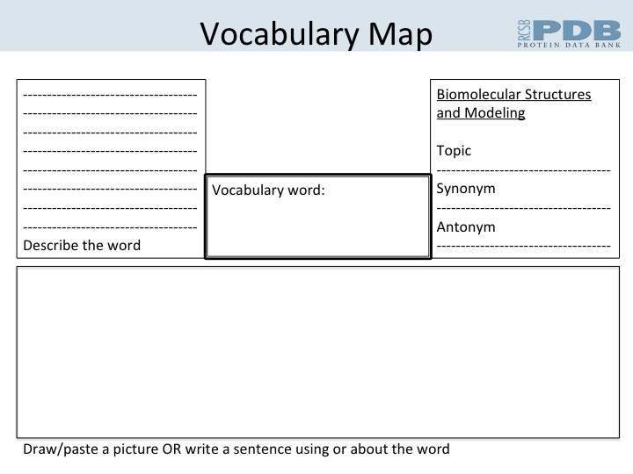



**Vocabulary Check List:**

Do you know the meanings of and how to use the following words?

A: A form DNA, alpha carbon, alpha helix, allosteric interaction, amide, amine, amino acid, angstrom, asymmetric unit, atom, Ala, Adenine

B: backbone, base pair, beta sheet, B-form DNA, biological assembly

C: carbohydrate, carbonyl group, carboxyl group, chirality, co-operativity, coenzyme, coordinates, covalent bonds, configuration, conformation, CPK colors, crystal, crystallography, Cys, Cytosine

D: dalton, deoxyribonucleic acid, DNA, domain, dimer, disulfide bonds, domain, Asp

E: electron microscopy, electron density, electrostatic interactions, ensemble, Glu

F: fatty acid, Phe

G: glycoprotein, Gly, Guanine

H: heterodimer, homodimer, hydrogen bond, hydrophobic interactions, hydrophilic, His

I: ionic interactions, Ile

J:

K: Lys

L: ligand, lipid, Leu

M: macromolecule, metal coordination, motif, Met

N: nucleotide, nucleoside, Nucleic Acid, NMR, Asn

O: oligomeric protein, omega,

P: Peptide, peptide bond, pi-pi interactions, phi, psi, phospho-diester linkage, polymer, polypeptide, primary structure, Protein, purine, pyrimidine, Pro

Q: quaternary structure, Gln

R: residue, ribonucleic acid (RNA), ribozyme, Ramachandran plot, Arg

S: secondary structure, saccharides, side chain, subunit, Ser

T: tertiary structure, torsion angle, Thr, Thymine

U: unit cell, Uracil,

V: van der Waal interactions, Val

W: Water, Watson-Crick interactions, Trp

X: X-ray crystallography

Y: Tyr

Z: Z-DNA, Zwitterion

For explanations and additional vocabulary see: <http://www.rcsb.org/pdb/staticHelp.do?p=help/glossary.html>

**Grouped Vocabulary Checklist:**

* **Types of atoms**: alpha carbon, backbone, carbonyl group, carboxyl group, amide, amine, side chain
* **Properties of atoms or groups of atoms**: chirality, coordinates, configuration, conformation, CPK colors, Torsion angle, Ramachandran plot
* **Types of macromolecules**: carbohydrate, protein, Nucleic acids, glycoprotein, Peptide, Protein, lipid, polymer, polypeptide
* **Building blocks**: amino acid, fatty acid, nucleotide, saccharide, residue, ligand
* **Amino acids**: Ala, Cys, Asp, Glu, Phe, Gly, His, Lys, Ile, Leu, Met, Gln, Pro, Asn, Arg, Ser, Thr, Val, Trp, Tyr
* **Protein secondary structure**: alpha helix, beta sheet
* **Protein portion and/or assembly**: asymmetric unit, unit cell, biological assembly, subunit, domain, motif, primary structure, secondary structure, tertiary structure, quaternary structure, oligomeric protein, dimer, heterodimer, homodimer
* **Nucleic acid Bases**: Adenine, Cytosine, Guanine, Thymine, Uracil, purine, pyrimidine
* **Nucleic acids**: A form DNA, B-form DNA, deoxyribonucleic acid, DNA, base pair, nucleotide, nucleoside, Z-DNA, ribonucleic acid (RNA)
* **Types of interactions**: allosteric interaction, co-operativity, covalent bonds, disulfide bonds, electrostatic interactions, hydrogen bond, hydrophobic interactions, hydrophilic interactions, ionic interactions, metal coordination, peptide bond, pi-pi interactions, van der Waal interactions, Watson-Crick interactions, phospho-diester linkage
* **Experimental of structural determination**: crystallography, electron microscopy, X-ray crystallography, NMR, electron density, ensemble, phi, psi,