Towards Grid Services for a Virtual Research Environment

G.B Wills¹, L Gilbert², Q Gee², H.C Davis², T Miles-Board¹, D.E Millard¹, L.A Carr¹, W Hall¹, and S Grange³
1. Intelligent Agent Multimedia Group,
2. Learning Technologies Group,
Electronics and Computer Science, University of Southampton, UK
{gbw, lg3, qg2,jhcd, tmb, dem, lac, wh}@ecs.soton.ac.uk
3 Royal College of Surgeons of England, London, UK
simon@grange.me.uk

Abstract

VOEU is a virtual university which we designed, implemented and deployed in the Wessex Region of the UK for use by Higher Surgical Trainees in the Orthopaedic domain. A particularly original part of this virtual university is the Virtual Research Environment (VRE) which provides the infrastructure to support trainee surgeons in carrying out and publishing research and clinical trails. The current implementation of the VRE is tightly coupled, but we are now engaged in a new project to redeploy the VRE as loosely coupled grid services. This paper describes the VRE, and discusses the advantages that will be achieved by implementing it as grid services.

1. The Virtual Orthopaedic University
The Virtual Orthopaedic University (VOEU) provides an infrastructure for clinicians to manage the administrative, research and educational workload of the university within the digital domain.
The VOEU system, as developed, includes the following components; the last two being the focus of this paper.
- Multimedia Educational Modules, which provide the declarative (factual) base of material for the education of the users [2].
- A Virtual Classroom environment for exchange of views, and monitoring of progress [8].
- Novel Modalities of Simulation [3],[4] for the emulation of surgical procedures for training and experimentation, focusing upon micro-surgery.
- A Virtual Observatory for the collection of data from simulation systems and the actual intra-operative data collection.
- A Virtual Research Environment (VRE) which allows HSTs and tutors to analyse data from existing journals, investigate hypotheses, comment on reviewed articles, and even prepare and submit articles for review. Part of the VRE is an e-Prints web based archive of peer-reviewed medical and technical material. In addition, tutors can capitalise on these reviews by including using them as part of the educational process as the subject of discussion; the discussion itself is also captured in the archive.
Combining the above components within one working environment, the virtual university infrastructure [5] aims to meet the needs of clinicians by combining clinical, educational and research duties. The end users for this VRE are the Higher Surgical Trainees (HSTs), who are qualified surgeons training to be consultants. They are not computer specialists, their study is work based and they are rarely co-located with other HSTs. During the six years of training they usually move post twelve times, and they are required to keep a logbook (e-Portfolio). Therefore they typify both the average scientist trying to collaborate on a project and a group of e-learners studying collaboratively in a partner institution, and they require tools that are easy to use for non computer science specialists.
An objective of the project was to provide integrated computer support across the research and educational cycles because these activities are intrinsically coupled as a part of the requirements of the surgeon’s Continuing Professional Development. They must undertake research and publish papers in order to achieve goals under the learning contracts with their Professional Colleges.

2. The Virtual Research Environment (VRE)

The Virtual Research Environment in the VOEU project has two main functions; it provides the data to support case based learning and the tools to aid surgeons in preparing research findings for publication. Orthopaedic surgical trials typically run for extended periods (up to 2 years), with postoperative assessment results being collected regularly. The collated results are then analysed and discussed by a team of surgeons before being disseminated to the wider orthopaedic community.

2.1 Schema Space

The schema space is the mechanism by which the Virtual Research Environment is configured to a particular e-learning community, through the formal specification of e-experimentation procedures relevant to that community [1]. This configuration is currently achieved using three different types of schema:

- Data schemas describe the exact nature of the experimental data (for example, specification of variable names, types, and possible values). In VOEU there are a number of data schemas for collecting orthopaedic clinical trial data.
- Experiment schemas describe experimental procedures or protocols. For example, a protocol could specify that any e-scientist conducting an experiment of type X needs to record an experiment description, statement of purpose and an outcome hypothesis. Human-readable guidelines are also included, to help HSTs meet the requirements of the protocol and to help reviewers to ensure that the requirements have been met. Context sensitive help is provided depending on role of the user in order to help them understand what should be in any dialogue box. As a simple example, the HST guidelines for the experiment description may state “summarise the content of the experiment”, whereas the reviewer sees “does the experiment description adequately summarise the content of the experiment?”
- Publication schemas describe the required format for submitting experimental results to relevant journals/conferences (for example: Abstract, Introduction, Background, Experimental Methods, Results, and Conclusions). As with experiment schemas, human-readable guidelines are also included in publication schemas. In VOEU there are currently two publication schemas presenting the submission formats for the Journal of Bone & Joint Surgery (JBJS) and the British Medical Journal (BMJ). Where possible, the publication schema also describes any mappings to the experiment protocol (for example, specifying that the experiment hypothesis should appear in the Experimental Methods section of the article). This allows outline preprint ‘previews’ to be generated automatically without requiring the HST to copy and paste information between protocol and preprint).

2.2 User Space

The user space is where HST uses the schema space to orchestrate practical data entry and collation, e-experimentation, and dissemination. The user space is further subdivided into three personalised areas My Logbook, My Experiments, and My Papers.
My Logbook (or e-portfolio) is an experiment logbook, in which experimental results can be entered (in accordance with a selected data schema). Logbook entries are subsequently added to the Virtual Research Environment community database, making data available (anonymously) to other community members.
My Experiments is a workspace for e-experiments, which the e-scientist works on. An e-scientist may be involved in an experiment in the capacity of lead investigator (initiates experiment and acts as co-ordinator and contact for duration of experiment), associate investigator (assistant), or reviewer (monitors the progress of the experiment and reviews its outcomes according to guidelines). Reviewers have read-only access to the experiment protocol and set-up. When a new experiment is initiated, a discussion facility is automatically set up to facilitate and record communication between the e-scientists involved (this is also the means by which reviewers can give feedback to the practitioners).

2.3 Example of Use

To illustrate how an HST may use the VRE, this section outlines the process of managing e-experiments from the perspective of a fictional trainee surgeon,

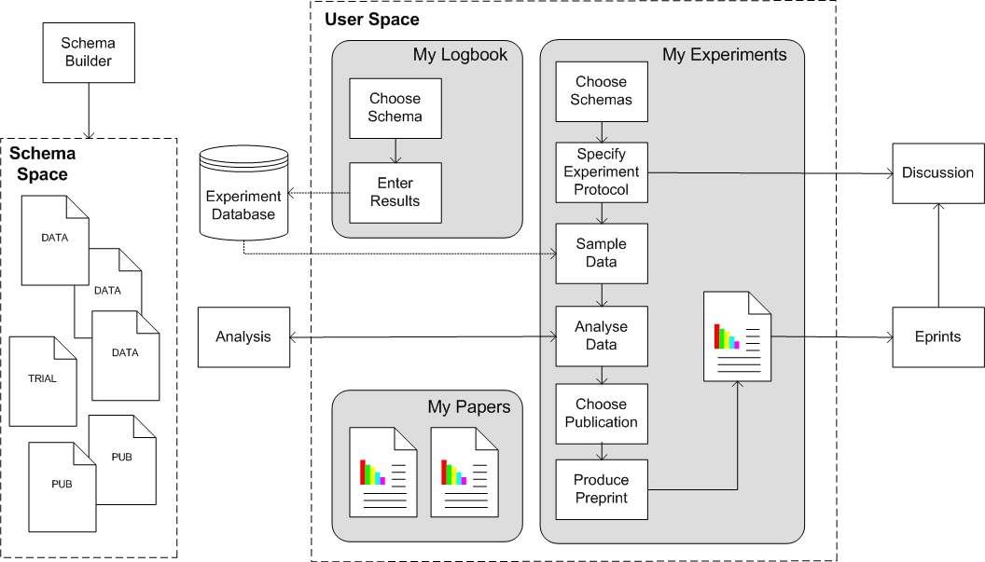
Figure 1 Workflow in the VRE Framework.

Sam. In Sam’s view of the VRE user space, Sam is shown to be currently working on three trials, undertaking a different role in each. Sam is the co-investigator in the “charcot joints” trial, is writing a systematic review of experiments in the “rotator cuff” trial, and is also a peer reviewer of the “tear size” trial. Sam has also entered several experimental records in the personal logbook (patient details, operative procedures, and assessment results), part of Sam’s e-portfolio.

Formalising Trial Protocol - To initiate a new trial, Sam first selects the experiment protocol from the available experiment schemas. The VRE then uses this schema to generate a number of data entry forms into which Sam enters specifics of the experiment. Guidelines for completing these forms are presented as “stretch text links” [6], which can be viewed or hidden as required. A tutor specifies the associate investigators and peer reviewers who will assist Sam on the trial. When created, the new trial will appear in Sam’s VRE user space, and also in the user spaces of the associate investigators and peer reviewers.

Selecting a Dataset - To create a dataset for the new trial, Sam searches the data repository for appropriate data used in previous trials for suitable cases or uploads new cases from Sam’s logbook. Since Sam has already specified the experiment schemas, only those cases matching this schema will be searched. Sam, and associate investigators, subsequently add 42 different experimental results to the trial, which can be viewed in tabulated form for visual comparison.

Analysing the Dataset - To perform analyses on the dataset, Sam and associate investigators choose from statistical methods offered by a distributed Analysis Engine. Using the experiment schemas and metadata from the Analysis Engine, the VRE tool is able to generate an entry form for each statistical method, which Sam can use to fine tune the analysis (specify test variables, groupings etc.). The Analysis Engine queues the requested analysis and notifies Sam when results are available. These results appear in Sam’s VRE user space, and can be viewed.

Discussing the Results - Having obtained some significant results from the statistical analyses, Sam then decides to create a pre-print, for discussion by the co-investigators on a discussion board created for the e-print. Sam, co-investigators, or a tutor can specify who is able to see the pre-print and comment on it. For the trial, the pre-print can be taken on to publication. In this case Sam selects the JBJS publication schema, and the VRE toolkit generates a pre-print template using the information Sam entered in the trial protocol. Sam fleshes out this template, following the JBJS guidelines provided, and specifies which analysis results should be included in the preprint. After previewing the pre-print, Sam submits it; behind the scenes the VRE tool submits the pre-print and its associated metadata to the community E-prints server (where it subsequently becomes available to the members of community), and makes the paper available in the user spaces of all the co-investigators.

The workflow is illustrated in Figure 1.

3. Grid services for a Virtual Research Environment.

The VOEU project is based on an integrated and tightly coupled architecture, making it difficult to expand as the user requirements change. The Collaborative Orthopaedic Research Environment (CORE) is a VRE, which takes as its foundations the VRE established in VOEU, taking the modules and developing them into Web services and supporting these services in a Service Oriented Architecture (SOA) [7] where flexible granular functional components expose service behaviours accessible to other applications via loosely coupled standards-based interfaces.
The CORE VRE project is developing a Grid/Web service based Virtual Research Environment demonstrator for supporting a critical subset of the e-science cycle: the collation and analysis of experimental results, the organisation of internal project discussions and the production of appropriate outline documents depending upon the requirements of conferences and journals selected for dissemination.
Wilson et al. [9] discuss in detail the advantages of using SOAs, but in our context the following particularly apply:
- Appropriate services can be used as required with new services being relatively easy to integrate in to the framework, allowing interoperability with similar systems
- Standardisation of the communication and description of the services means that third party services can easily be incorporated into the VRE as required.
- The relative ease with which services can be incorporated into the VRE means there is less danger of technology ‘lock in’.
The CORE project is being implemented as a toolkit of generic components. Figure 2 illustrates the CORE Framework concept, in the context of an e-science community Web site and integrated Grid/Web-based services. The grid services will enable researcher and learners to run simulation and data analysis on a scale not possible today.
The focus of the generic toolkit components in CORE will be a Virtual Bone Biology Laboratory, incorporating the basic science disciplines of molecular and tissue biology, engineering and computing with allied medical disciplines of pharmacology, prosthetics, trials management and the clinical disciplines concentrating upon musculoskeletal applications in rheumatology and orthopaedics. The Bone laboratory aims are to prepare the processes and test methods for the development of new technologies for the information management, and construction of technologies on the nanometric scale. The Core will need to provide Grid services for the simulation and modelling of bone and soft tissue biology, analysis of large scale experiments and the modelling of nanometric tissue units. The Core Bone laboratory will provide a post-graduate training experience for researchers and clinicians with a background in bioengineering initially treating musculoskeletal problems with emphasis upon training the next generation of clinicians and scientists.
But there are reasons beyond saleability that Grid services make sense in such learning scenarios. Learning is more than a series of quick transactions and needs glue mechanism to orchestrate the services, manage state, and provide security and trust across a range of services.

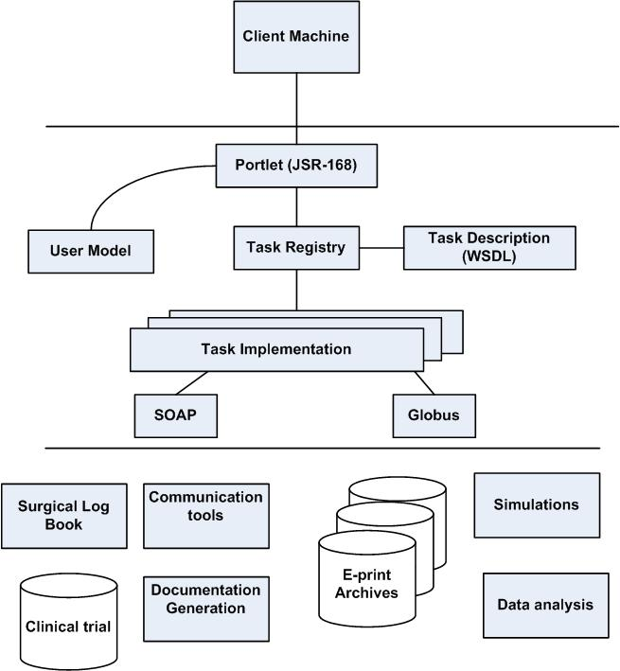
Figure 2: Overview of the VRE Infrastructure

4. Conclusions and Future Work

The development of a Virtual Orthopaedic European University described in this paper is underpinned by a pedagogical approach built on current education research. This paper has focused on a specific framework, the Virtual Research Environment, which supports the development and dissemination of documents by assisting authors in collating and analysing experimental results, organising internal project discussions, and producing papers. The system provides a distributed architecture for institutions to manage multiple centres, advancing surgical standards through education and research. The tools are generic, applicable across surgical and medical training. The system has been deployed in a local hospital and HSTs validated the trials. With the advent of virtual infrastructures, there is the possibility managing most of the administrative, research and educational workload of the university within the digital domain. This has potentially huge benefits for surgeons, providing greater access to information without the friction associated with traditional infrastructures. The CORE project will take the VOEU VRE and decouple the process by using a SOA and Grid services to support the virtual experiments on Tissue Growth in a virtual Bone laboratory. CORE will enables HSTs to collect and analyse experimental results from their own or other people’s experiments, organise internal project discussions, and produce appropriate documents, the project should have a major impact on a number of areas which include:
- Being able to keep track of the research administration: trial protocol, ethical approval, and workflow as the trial progress,
- Enabling access to research data from various trials and in formats that allow analysis of the data,
- Allowing easier meta-analysis or thematic reviews,
- Monitoring the effectiveness of surgical interventions,
- Enabling a consortium to write appropriate documents for dissemination (medical reports, journal articles, etc)
- Producing up to date learning and teaching material.
The current vision for the Grid focuses only upon the immediate aspects of e-Science the experiments, analyses and meetings which occur over the duration of a project. As well as these synchronic aspects, any scientific effort (and e-Scientific efforts in particular) will have diachronic features. These are collaborative activities extending through time, enabling the influence of the project to carry on beyond its funded timescale and disseminating its knowledge beyond the boundaries of the original collaboration. These activities are a well-known part of the scientist’s profession (publishing papers, publishing data, rerunning experiments and checking others’ results, comparing approaches from different projects, generalising or specialising the work of others, and teaching). The current deployment of Web technologies increases the effectiveness of this loose-coupled collaboration. There is also a looser coupling that exists between researchers-as-educators and their students, particularly in the context of higher education. The accepted picture of e-science could be enlarged from its current focus on experimentation and analysis to feature these processes of wider significance, since without these aspects of diachronic collaboration there would be no ongoing science and, indeed, no scientists.

5. Acknowledgements

Part of this work was funded by The European Commission under the Virtual Orthopaedic European University project, IST-1999-13079, Information Society Technology Program.

6. References

- Carr, L., Miles-Board, T., Wills, G., Power, G., Bailey, C., Hall, W. and Grange, S. (2004) Extending the Role of Digital Library: Computer Support for Creating Articles. In Proceedings of The Fifteenth ACM Conference on Hypertext and Hypermedi , University of California, Santa Cruz, USA

- Conole G., Wills G., Carr L., Vadcard L., Hall W., & Grange S. (2003). Building a Virtual University for Orthopaedics. EdMedia 2003(1), 22-27. http://dl.aace.org/12697.

- Grange S., Bunker T., Cooper J. Networking virtual reality for shoulder arthroscopy. British Journal of Healthcare Computing 13[10], 26-28. 1996.

- Grange S., Bunker T., Cooper J. Exeter Virtual Worlds Shoulder Arthroscopy Simulator. London: Brunel Univ Press, 1997.

- Hazemi R, Hailes S. Reinventing the Academy. In: Wilbur S, Hazemi R, Hailes S, editors. The Digital University. London: Springer, 1998: 7-24

- Nelson T. H.. Computer Lib/Dream Machines. Tempus Books, 1987.

- Smythe, C., Evdemon, J., Sim, S., & Thorne, S. (2004) Basic Architectural Principles for Learning Technology Systems. from http://www.imsglobal.org/

- Wills, G., Woukeu, A., Bailey, C., Ong, A., Carr, L., Conole, G., Hall, W. and Grange, S. (2004) Ontological Driven Learning Agreements. In Proceedings of EDMEDIA 2004 pp.217-222.

- Wilson, Blinco & Rehak. Service-Oriented Frameworks: Modelling the infrastructure for the next generation of e-Learning Systems. Available at http://www.jisc.ac.uk/uploaded_documents/AltilabServiceOrientedFrameworks.pdf: 2004

